San Jose State University

EE250 (Section 2) Fall 2019 Prof. Kamali

Problem Set #1

1. Problem 2.34
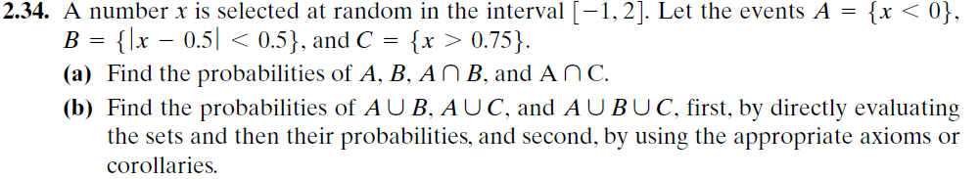

2. Problem 2.81
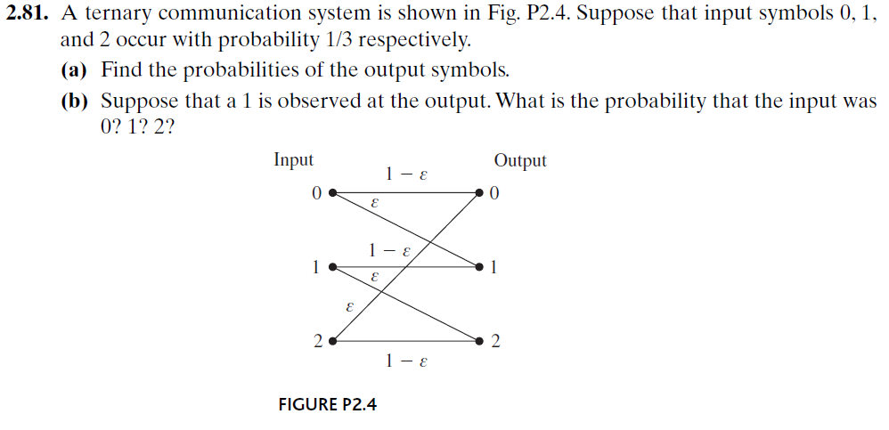

3. Problem 2.127
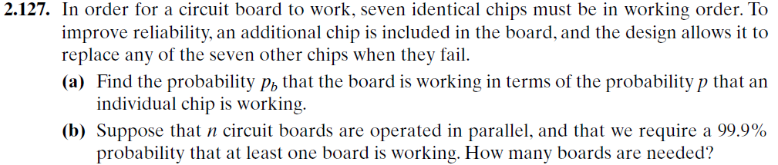

- [Midterm Problem, Fall 2005] What is the probability that five guests of a twenty floor hotel all stay in different floors (no pair of them are in the same floor) if
- Any guest can stay in any floor?
- Two smokers of the group must stay in four smoking floors and the rest must stay in sixteen non-smoking floors.

- [Midterm Problem, Spring 2008] Two dices (one black and one white) are rolled simultaneously five times. What is the probability that the number on the black dice be larger than the number on the white dice more than twice?

- [Midterm Problem, Fall 2010] Suppose  and are two real numbers picked randomly and independently between 0 and 1. Find 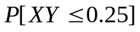.

- [Midterm Problem, Spring 2015] A fair coin is tossed ten times.
- What is the probability that all ten tosses produce the same result?
- What is the probability that the results alternate, i.e., Tail is followed by Head and Head is followed by Tail?
- What is the probability that the first five tosses produce identical results?

- [Midterm Problem, Fall 2015] A point M is chosen in random within the unit square (as shown in the following figure).
- What is the probability that M is closer to Y than to X?
- If M is known to be closer to Y than to X, what is the probability that it is closer to Z than to X?

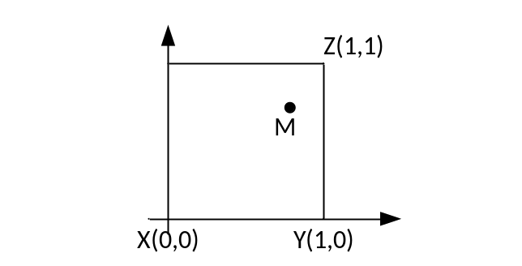
- [Midterm Problem, Fall 2017] In a processing board, there is an important component (A) whose failure is likely going to result in the failure of the board. Specifically, if A fails, board will fail with the probability of 90%. On the other hand, if A is operational, board fails with the probability of only 5%. Assume A fails with probability of 10%.

- Find the probability of the board’s failure.
- What is the probability that an observed board’s failure has been caused by the failure of A?

